**Fundamentals of Programming**

**Lab Journal - Lab # 10**

Name: Mohammad Arsalan Shakil

Enrollment #: 01-134181-032

Class: BS(CS)-1A

**Objective**

This lab will cover built-in functions

**Exercise 1**

**Include the desired libraries for each function.** Write the output and **write which operation is being performed** in each code.

**#include<time.h>**

**#include<cstdlib.h>**

|  |  |  |
| --- | --- | --- |
| 1. | cout << time(0); | Output:    Operation:  Seconds count from 1 July 1970 to the time statement executed. |
| 2. | int anyRandomNumber1 = rand();  int anyRandomNumber2 = rand();  int anyRandomNumber3 = rand();  cout << anyRandomNumber1<<endl;  cout << anyRandomNumber2<<endl;  cout << anyRandomNumber3 << endl; | Output:    Operation:  Random Numbers Generated |
| 3. | //In the range 0 to 9  int anyRandomNumber1 = rand()%10;  int anyRandomNumber2 = rand()%10;  int anyRandomNumber3 = rand()%10;  cout << anyRandomNumber1<<endl;  cout << anyRandomNumber2<<endl;  cout << anyRandomNumber3 << endl; | Output:    Operation:  Random Numbers Generated from the range 0-9 |
| 4 | //In the range 1 to 10  int anyRandomNumber1 = rand()%10 + 1;  int anyRandomNumber2 = rand()%10 + 1;  int anyRandomNumber3 = rand()%10 + 1;  cout << anyRandomNumber1<<endl;  cout << anyRandomNumber2<<endl;  cout << anyRandomNumber3 << endl; | Output:    Operation:  Random Numbers Generated from the range 1-10 |
| 5. | int seed = 20;  srand(seed);  int anyRandomNumber1 = rand() % 10 + 1;  int anyRandomNumber2 = rand() % 10 + 1;  int anyRandomNumber3 = rand() % 10 + 1;  cout << anyRandomNumber1 << endl;  cout << anyRandomNumber2 << endl;  cout << anyRandomNumber3 << endl; | Output:    Operation:  Random Number generated from a fixed starting position |
| 6. | Change the value of seed in the above task now and repeat it. Notice that the same sequence of random numbers will be generated for a one particular seed value.  int seed = 2;  srand(seed);  int anyRandomNumber1 = rand() % 10 + 1;  int anyRandomNumber2 = rand() % 10 + 1;  int anyRandomNumber3 = rand() % 10 + 1;  cout << anyRandomNumber1 << endl;  cout << anyRandomNumber2 << endl;  cout << anyRandomNumber3 << endl; | Output:    Operation:  Random Number generated from a fixed starting position and different from the above |

**#include<math.h>**

|  |  |  |
| --- | --- | --- |
| 7. | int distanceAtoB = 560;  int distanceAtoC = 730;  int distanceBtoC = distanceAtoB - distanceAtoC;  cout << distanceBtoC<<endl;    distanceBtoC = abs(distanceBtoC);  cout << distanceBtoC<<endl; | Output:    Operation:  Use of math.h library and the function absolute value |
| 8. | //e ^ 6  cout << exp(6)<<endl;  // e ^ 123  cout << exp(123)<<endl;  //e ^ 0  cout << exp(0) << endl; | Output:    Operation: $e^{x}$ Used from C++ library math.h |
| 9. | int cube = pow(2, 3);  cout << cube << endl; | Output:    Operation: $x^{y}$ Used from C++ library math.h |
| 10 | float theta = 45;  cout << cos(theta) << endl;  cout << sin(theta) << endl;  cout << tan(theta) << endl; | Output:    Operation:  Use of trignometic equations from math.h |
| 11 | float number = 29.5;  cout << ceil(number) << endl;  cout << floor(number) << endl; | Output:    Operation:  Ceil rounds of to upper value  Floor rounds of to lower value |

**#include<ctype.h>**

|  |  |  |
| --- | --- | --- |
| 12. | cout << isdigit('a') << endl;  cout << isdigit('5') << endl<<endl;  cout << isalpha('6') << endl;  cout << isalpha('z') << endl<<endl;    cout << isalnum('a') << endl;  cout << isalnum('4') << endl;  cout << isalnum('+') << endl; | Output:    Operation: |
| 13. | cout << isspace(' ') << endl;  cout << islower('A') << endl;  cout << isupper('A') << endl;  cout << ispunct(',') << endl; | Output:    Operation: |
| 14. | char x = tolower('A');  char y = toupper('h');  cout << x << endl;  cout << y << endl; | Output:    Operation:  Lower Alphabets  Upper Alphabets |

**#include<iomanip>**

|  |  |  |
| --- | --- | --- |
| 15. | double f = 3.14159;  cout << setprecision(3) << f << endl;  cout << setprecision(9) << f << endl;  cout<<fixed;  cout << setprecision(3) << f << endl;  cout << setprecision(9) << f << endl; | Output:    Operation:  Number of Decimals set |
| 16. | double f = 555;  string s = "HEllo!";  cout << setw(50)<< endl;  cout << f << endl;  cout << setw(50) << endl;  cout << s<<endl; | Output:    Operation:  Position set for output |

**Exercise 2**

Write a program that tells a missing side of a right-angled triangle. It asks the user which side of the triangle is missing (in a string). It then finds that missing side using the famous Pythagoras theorem. Use the required built-in functions.

Note: You can ask user to enter any of these three inputs (perpendicular, base, hypotenuse). If the user enters wrong spelling i.e. any string other than above three, display WRONG Input on screen and ask input again. You can use an infinite loop for asking input again and again.

**Code :**

#include<iostream>

#include<time.h>

#include<conio.h>

#include<iomanip>

#include<ctype.h>

#include<cstring>

#include<string>

#include<math.h>

using namespace std;

int main()

{

string s;

int ch = 0;

double base = 0, perpendicular = 0, hyp = 0;

cout << "Enter side to find value : " << endl;

getline(cin, s);

do

{

if (s == "hyp" || s == "HYP" || s == "hypotenuse" || s == "h")

{

ch = 1;

cout << "Enter values for Base and Perpendicular : " << endl;

cout << "Base : ";

cin >> base;

cout << "Perpendicular : ";

cin >> perpendicular;

hyp = sqrt((pow(base, 2) + pow(perpendicular, 2)));

cout << endl << "Hyp : " << hyp << endl;

}

else if (s == "perpendicular" || s == "pepend" || s == "p")

{

ch = 1;

cout << "Enter values for Base and Hyp : " << endl;

cout << "Base : ";

cin >> base;

cout << "Hyp : ";

cin >> hyp;

perpendicular = sqrt((pow(base, 2) - pow(hyp, 2)));

cout << endl << "Perpendicular" << perpendicular << endl;

}

else if (s == "base" || s == "b")

{

ch = 1;

cout << "Enter values for Perpendicular and Hyp : " << endl;

cout << "Perpendicular : ";

cin >> perpendicular;

cout << "Hyp : ";

cin >> hyp;

base = sqrt((pow(perpendicular, 2) - pow(hyp, 2)));

cout << endl << "Base : " << base << endl;

}

else

{

cout << "Wrong Selection" << endl << endl;

cout << "Enter side to find value : " << endl;

getline(cin, s);

ch = 0;

}

} while (ch != 1);

system("pause");

return 0;

_getch();

}

**Output :**

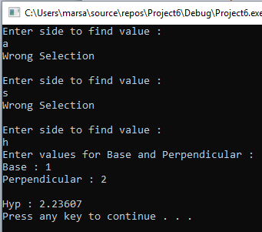

**Exercise 3**

Write a C++ program that generate a series of 70 random numbers in the range 1 to 50 using the functions rand() and srand(). For the first 35 random numbers use the seed value from system’s clock. For the next 35 numbers of the sequence use seed value which is taken from user.

Note: You will take seed value from user once at the start of the program, not in the loop.

**Code :**

#include<iostream>

#include<time.h>

#include<conio.h>

#include<iomanip>

#include<ctype.h>

#include<cstring>

#include<string>

#include<math.h>

using namespace std;

int main()

{

int seed;

srand(time(0));

for (int i = 0; i < 35; i++)

{

int randomnumber = (rand() % 50) + 1;

cout << randomnumber << endl;

}

cout << "Enter Value for Seed : ";

cin >> seed;

srand(seed);

for (int j = 35; j < 70; j++)

{

int randomnumber1 = (rand() % 50) + 1;

cout << randomnumber1 << endl;

}

system("pause");

return 0;

}

**Output :**

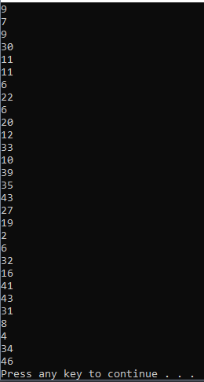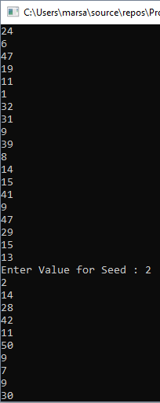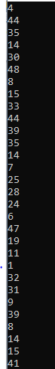

**Exercise 4**

Make the magic 8 ball game.

About the game: It is a ball that has 8 different general responses to your questions saved in it. Every time the user spins it, it gives an answer randomly.

It can be implemented in many ways in C++.

Simplest Implementation for the lab:

Save 8 strings in an array of strings. Those 8 strings should be general responses/answers to any question.

Display on screen “Ask your question”. And get the question from user in any string using getline function. You will not do anything with the question since you have to display answers randomly.

Now generate a random number from 0 to 7 and display the string at that index of your array-of-strings to user.

Bonus: Save the array of strings for different answers in a text file.

**Code :**

#include<iostream>

#include<time.h>

#include<conio.h>

#include<iomanip>

#include<ctype.h>

#include<cstring>

#include<string>

#include<math.h>

#include<fstream>

using namespace std;

void main()

{

string que, Ball[8];

Ball[0] = "No";

Ball[1] = "Yes";

Ball[2] = "Perhaps...";

Ball[3] = "Most definetly yes";

Ball[4] = "Almost positively not";

Ball[5] = "I think so...";

Ball[6] = "Maybe";

Ball[7] = "Definatly no";

cout << "Welcome to Magic 8 ball game" << endl;

cout << "Enter your question : ";

getline(cin, que);

srand(time(0));

cout << Ball[rand() % 8] << endl;

system("pause");

}

**Output :**

